**Software Requirement Specification   
for  
HR Medical Center  
(HR-SRS)**

Version:1.1

Date: ”July 21, 2022”

Submitted by:  
 1. Hasibullah Aman  
 2. Rohullah Akbari

Table of Contents

Revision History 5

1.introduction 6

1.1 Purpose 6

1.2 Project Scope 6

1.3 Terms, Acronyms 7

1.4 References 7

2. Over All Description 7

2.1 Product perspective 8

2.2 Product features 8

2.2.1 Registration 8

2.2.2 Admin 8

2.2.3 Pharmacy 8

2.2.4 Patient Module 9

2.2.5: Doctors Module 9

2.3 User Class and Characteristic 9

2.3.1 Patients 9

2.3.2 Doctors 9

2.3.3 Administrator 9

2.4 Operating Environment 10

2.5 Design and implementation constraints 10

2.6 Assumptions and Dependencies 10

2.6.1 Usability 10

2.6.2 User Request 10

2.6.3 Requirements 10

And some other Assumptions: 10

3. System Features 11

3.1 Registration 11

3.2 Reception Module 11

3.3 Admin 11

4. Non-Functional Requirement 11

4.1 Performance 11

4.2 Usability 11

4.3 Maintainability 11

4.4 Reliability 12

5. External Interface Requirements 12

5.1 User Interface 12

5.2 Hardware Interface 12

5.3 Communication Interface 12

6. Detailed Use Case 13

Need to Work on 14

Prerequisites: 14

Languages and Technologies used: 14

Steps to run the project in your computer: 15

SOFTWARES USED 15

Starting Apache and MySQL in XAMPP 15

Getting into the project: 16

Make appointment 17

Registration Page 18

Login page 19

Patient Dashboard Page 21

Patient Appointment Page 21

Patient Appointment History Page 22

Patient prescription page 22

Doctor login Page 23

Doctor Dashboard 24

Doctor Appointment 24

Doctor Prescription list 25

Admin 26

Admin login 26

Admin dashboard 26

Admin View Doctors page 27

Doctor view patient List 27

Doctor appointment Details 28

Doctor Prescription list 28

Admin Add doctor page 29

Client contact 30

Admin queries page 30

Create Appointment test case 32

Use case testing 32

Unit testing 32

View patient Report Testcase 33

Use case testcase 33

Unit testcase 33

Search Appointment Testcase 34

Unit test Testcase 34

Manage Staff testcase 35

Use case testcase 35

Unit test testcase 36

Delete Staff 36

Edit Staff 37

# Revision History

|  |  |  |  |
| --- | --- | --- | --- |
| **Name** | **Date** | **Reason For Changes** | **Version** |
|  |  |  |  |
|  |  |  |  |

# 1.introduction

My project Hospital Management system includes registration of patients, storing their disease details into the system. My software has the facility to give a unique id for every patient and stores the details of every patient. The Hospital  
Management System can be used by entering respective username and password. It is accessible either by an administrator or receptionist. Only the respective person can add data in the database. The data can be retrieved easily. The interface is very user-friendly.

## Purpose

A hospital management system is a software designed to manage all the areas of a hospital such as medical, financial, administrative and the corresponding  
processing of services ,The system should have a page that can determine the appointment time for patients who want to make an appointment with doctors. Doctors advise patients to reserve their time to meet new patient a patient can close our specialized departments and go to the hospital.

## 1.2 Project Scope

Daily functions like patient registration, managing admission and overall management of various departments can be easily performed with higher accuracy after the accessing the HR Medical Center website. The modules of hospital management software are user-friendly and easy to access.

Currently HR medical Center is using a manual system to handle the hospital process, When patients arrive they make an appointment at the reception to consult a Doctor.  
These are being recorded in a file. Then again the patients diagnosed symptoms related disease details, ward details and other necessary details are being recorded and those files are being stored in special locations.

We plan to overcome the above mentioned problems through a standalone application, to manage the major functions of the Hospital System.

* A patient should be able to get information about our center without visiting our center
* Get to know the specialized staff of doctors that our center has assembled
* Know the facilities that are available in our hospital
* Patients can be informed and benefit from our free services
* able to schedule appointments with doctors
* On the other hand, our doctors can give appointments to new patients.

## 1.3 Terms, Acronyms

DFD: – Data Flow Diagram

HR-SRS:- HR Software Requirement Specification

HRMC: - HR Medical Center  
IDE: – Integrated Development Environment  
SQL: – Structured Query Language  
SRS: – Software Requirement Specification.  
GUI: - Graphical User Interface  
EDM: Entity data Model  
Ms Sql: Microsoft Structured Query Language

## 1.4 References

1. <https://en.wikipedia.org/wiki/Health_administration>

2. [www.apollohospitals.com](http://www.apollohospitals.com)

3. <https://www.scribd.com/doc/60567651/apollo>

4. <http://www.slideshare.net/HimaniChopra/apollo>

5. http://www.dotnetfunda.com/articles/show/1052/sample-software-requirements-specification-forhospital-info-managemen

# 2. Over All Description

## 2.1 Product perspective

Our website is intended to use in order to improve medical treatments and  
make it easy for healthcare workers to store patient history and make appointments online etc.

hospitals still spend considerable time and money on managing patient data and scheduling appointments etc. The reason for this is that hospital requirements differ greatly from those of other companies. Our health care system is an online application tailored to the needs of a hospital.

The fully functional automated hospital management system which will be developed through this project will eliminate the disadvantages caused by the manual system by improving the reliability, efficiency and performance. The usage of a database to store patient, employee, stock details etc. will accommodate easy access, retrieval, search and manipulation of data. The access limitations provided through access privilege levels will enhance the security of the system. The system will facilitate concurrent access and convenient management of activities of the medical center.

## 2.2 Product features

2.2.1 Registration: When a patient is admitted, the front-desk staff checks to see if the patient is already registered with the hospital. If he is, his/her Personal Health Number (PHN) is entered into the computer. Otherwise a new Personal Health Number is given to this patient. The patient’s information such as date of birth, address and telephone number is also entered into computer system.

2.2.2 Admin: This module provides all main hospital entry details such as consultation details, specialization of the doctor, consultancy fees and service fees.

2.2.3 Pharmacy: All medical items are covered in this module. This module supports Item Master, Drugs receipts, problem handling, material return, retail bill generation, inventory maintenance. It also helps to meet both IPD and OPD Pharmaceuticals requirements.

2.2.4 Patient Module: The different functionalities of the module are listed below:

* Search Reposts
* Search his record
* Make appointment
* Use our free service

2.2.5: Doctors Module:

* Add patients report
* Give Prescriptions
* Accept/reject appointment
* Take appointment time for patient

## 2.3 User Class and Characteristic

In our healthcare system we have three main users i.e. patients, doctors, admin. Following are the main functionalities and characteristics of them.

2.3.1 Patients: patient shale to be able to:

* Create his/her Account
* Book an appointment
* Cancel an appointment
* Search medicine

2.3.2 Doctors: Doctors shale to be able to:

* Create his/her Account
* Edit Personal Account
* Add New patient
* Cancel appointment

2.3.3 Administrator: Admin shale to be able to:

* Active or de active a doctor
* Create a doctor’s account

## 2.4 Operating Environment

1. The System shall operate correctly with the following web browsers: Firefox  
   versions 28 through 48; Google Chrome (all versions); and Apple Safari versions 8.0 through 11.1
2. The system shall use MYSQL database for storing and maintaining record of the health care patients, doctors and their appointments etc.

## 2.5 Design and implementation constraints

1. The system shall use the open source tools.
2. The system should work on any internet browser with GUI whether the underlying Operating System is Windows.

## 2.6 Assumptions and Dependencies

Following are the assumptions and dependencies for our software system:

2.6.1 Usability: It is assumed that all user web pages should be in accordance with standardized colors and fonts. The users will receive on the-spot instructions on the step in the presentation of the Web pages.

2.6.2 User Request: The database of the system will manage without default a maximum of 50 users.

2.6.3 Requirements: It is assumed that requirements will not change for the software project over time

And some other Assumptions:

● Each user must have a valid user id and password  
● Server must be running for the system to function  
● Users must log in to the system to access any record.  
● Only the Administrator can delete records.

# 3. System Features

Following are the main features of our healthcare system.

3.1 Registration: This module allows patient information to be recorded and IPD and OPD patient Inquiries to be handled. After registration, a unique ID is produced for each patient. This helps to manage customer relationships and maintains the patient's medical history.

3.2 Reception Module:

* Doctor visit schedule
* Doctor Appointment Scheduling
* Enquiry of patient
* Find history of patient enquired

3.3 Admin: his module provides all main hospital entry details such as consultation details, specialization of the doctor.

# 4. Non-Functional Requirement

4.1 Performance

The average response time per every user click shall be less than 4 seconds. And the maximum average time per every click shall be less than 6 seconds.

4.2 Usability

The system user interface shall be user friendly. i.e. the minimum amount of time taken by novice user to learn the system shall be 15 minutes*.*

## 4.3 Maintainability

The system can make new changes on the basis of the requirements, if demanded after completion of the system. The maintainability of the system can be done by integrating new modules and offering new solutions for the raised problems.

## 4.4 Reliability

* The system shall have less than 6 hours downtime per two months
* Maximum Bugs per 1000 lines should not be greater than 9

5. External Interface Requirements

5.1 User Interface

I will extend some picture of my project when I complete it.

## 5.2 Hardware Interface

* Processor: Pentium IV AND motherboard
* RAM: 512 or Above
* Hard disk: 40 GB or above
* Input Device: Key bord, Mouse
* Output Device: Monitor, VGA

## 5.3 Communication Interface

* NIC (Network Interface Card) - It is a computer hardware component that allows a computer to connect to a network. NICs may be used for both wired and wireless connections.
* CAT 5 network cable- for high signal integrity
* TCP/IP protocol- Internet service provider to access and share information over the Internet.
* Ethernet Communications Interface- Ethernet is a frame-based computer network technology for local area networks (LANs)
* Ubiquitous, easy to set up and easy to use. Low cost and high data transmission rates.

# 6. Detailed Use Case

HR Medical Center

User Documentation

Need to Work on:

1. Ability to accept the appointment by the doctor to acknowledge the patient that their appointment has been approved.
2. User should not be allowed to register if he/she tries to provide the already registered email ID.
3. The password should be encrypted and the password field shouldn't be displayed in the admin panel.
4. Implementation of pagination for all the list view across the application.
5. Bug fix - Bill payment receipt contains multiple record if the patient has associated with the same doctor multiple times.
6. Addition of more fields in the prescription statement to make it more specific one.
7. Addition of more details on payment - such as date of the payment made, amount paid, etc.
8. Complete Other page Like Learn mor the first page, about us, Services Component, Specialist blog for every Doctor, Counter section, and Post section.
9. Our project also has a bug in one part, when a patient registers himself, at the same time, he cannot make an appointment with the doctor, and he has to leave the dashboard again and log in twice, which I honestly could not solve the problem. (N2 description)
10. Implementation of export button in admin module to export all details to an excel sheet.

# Prerequisites:

1. Install XAMPP web server
2. Any Editor (Preferably VS Code or Sublime Text)
3. Any web browser with latest version

# Languages and Technologies used:

1. HTML5/CSS3
2. JavaScript (to create dynamically updating content)
3. Bootstrap (An HTML, CSS, and JS library)
4. XAMPP (A web server by Apache Friends)
5. PHP

# Steps to run the project in your computer:

1. Download and install XAMPP in your computer
2. Clone or download the repository
3. Extract all the files and move it to the 'htdocs' folder of your XAMPP directory.
4. Start the Apache and Mysql in your XAMPP control panel.
5. Open your web browser and type 'localhost/phpmyadmin'
6. In phpmyadmin page, create a new database from the left panel and name it as 'myhmsdb'.
7. Import the file 'myhmsdb.sql' inside your newly created database and click ok.
8. Open a new tab and type 'localhost/foldername' in the url of your browser

SOFTWARES USED**:**

* XAMPP was installed on the Ubuntu 20.0 machine and APACHE2 Server and MySQL were initialized. And, files were built inside opt/lampp/htdocs/myhmsp
* Visual Studio Code V (1.69) used as a text editor.
* Google Chrome Version 103.0.5060.114 was used to run the project.

Starting Apache and MySQL in XAMPP[1]:

The XAMPP Control Panel allows you to manually start and stop Apache and MySQL. To start Apache or MySQL manually.

[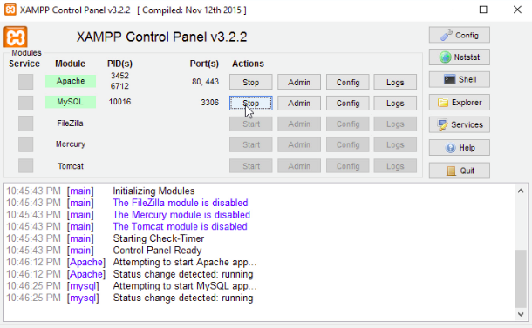](https://user-images.githubusercontent.com/36665975/59350977-fcc68900-8d3a-11e9-9450-e5c478497caa.png)

# Getting into the project:

-The website that we have created for HR Medical center has a page called Home in the first part, which is considered the first page of the site, which can be used to refer to all the parts that have been added to the site. and returned twice.

-Click on any button and you will be redirected to the corresponding page.

-You can get information about the hospital in the About us section.

-In the Services section, you can see all the services offered by the hospital.

-In the Our top Specialists section, you can get to know the top specialists of the hospital and get your information.

-In the People's Review section, you can find people's opinions about our center.

-In the Make an appointment now section, you can schedule your appointment with your respective doctor, which of course will direct you to the login page.

-In the Our Post section, you can read articles and scientific topics written by doctors or hospital personnel.

-And in the end, you will have ways to communicate with us.

-In the Header part of our site, we have an option called contact, when we click on this part, it will take us to the contact page.

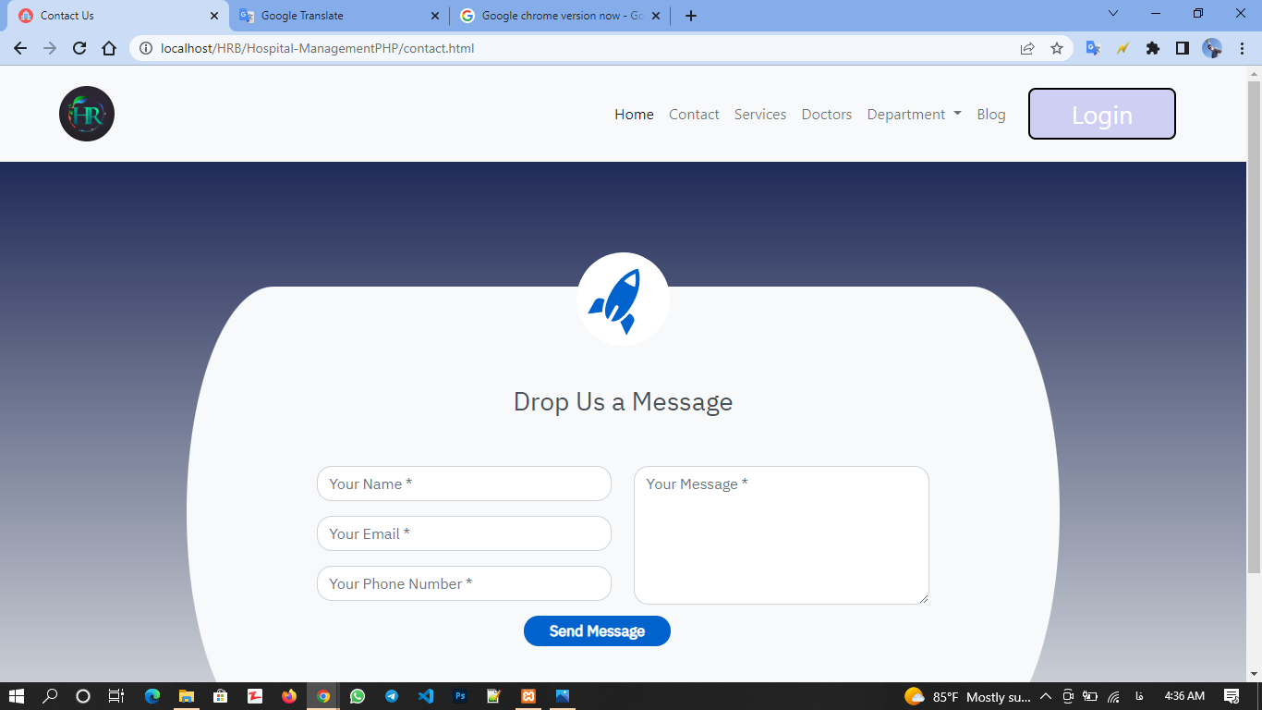

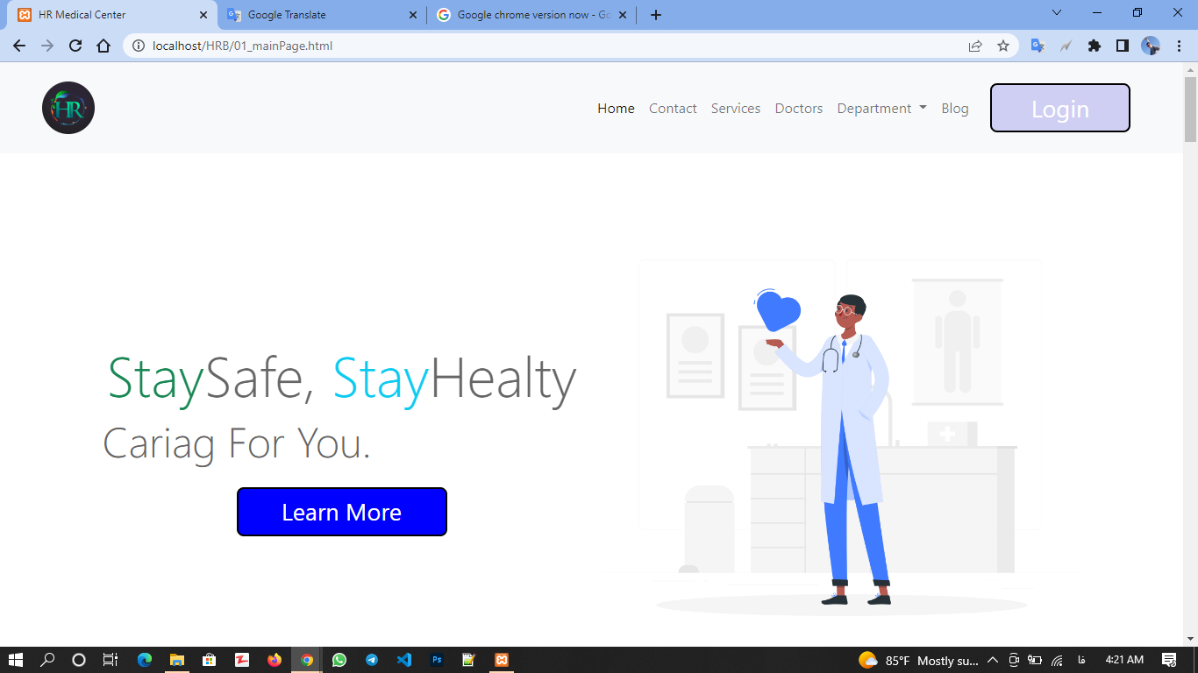Make appointment: If you want to make an appointment with the doctor, you can click on the Learn more section or use the Login section.

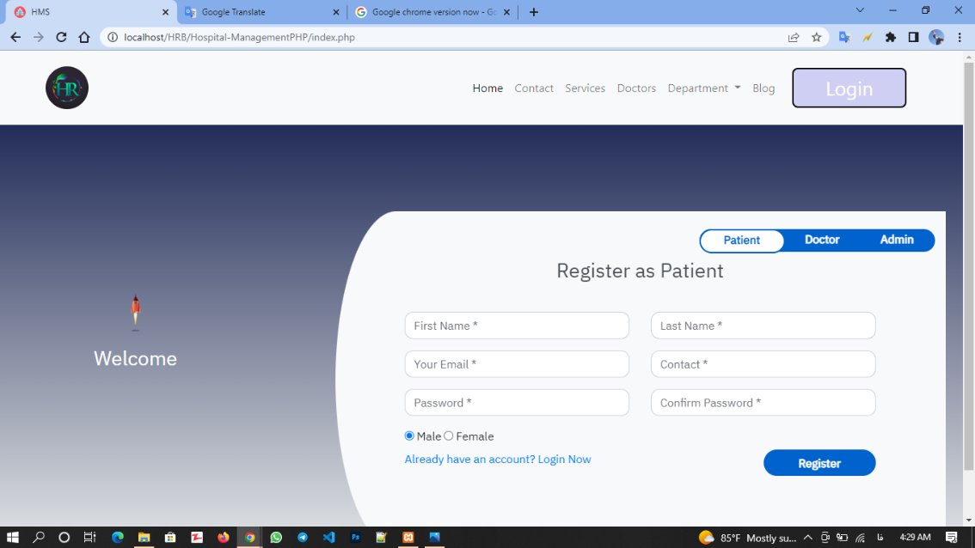-After you click on the Learn more or Login sections, you will be directed to such a page.

Registration Page: In this section, whether you are a patient, a doctor, or a site administrator, you can enter the site from your respective section, or if you are sick and do not have an account, you can create a new account for yourself.

Let's assume that a person named Ahmed wants to make an appointment with his specific doctor. When he clicks on Login, he will be directed to this page.

Ahmad's account here has the following two states:

Ahmad’s Account

Login page: In the second step, if Ahmed already has an account in this center, he can use his previous account and enter the system, he can click on the two sections below and enter the login page.

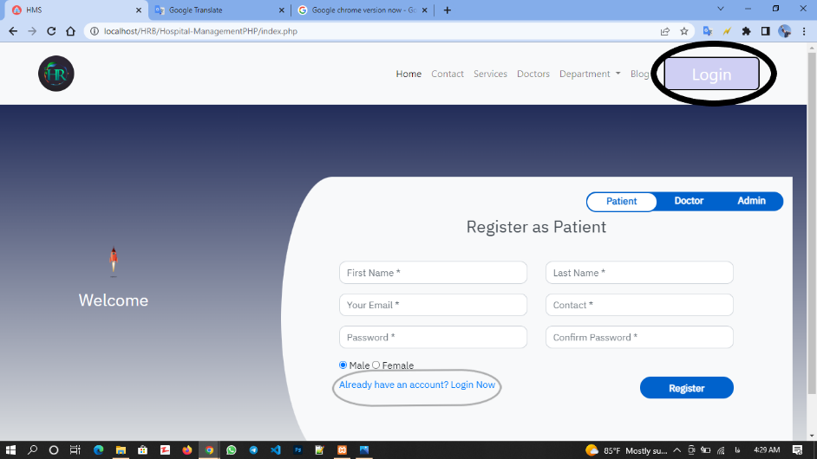

Then Ahmad will enter the login page.

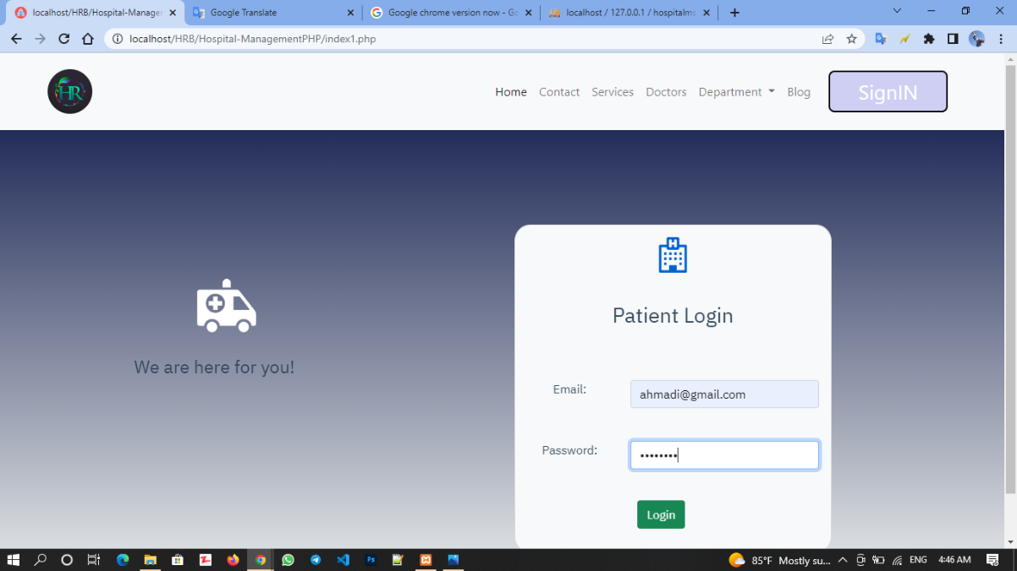

who can write his email and password, which has the following two modes.

After Ahmad enters her Email and Password, the system will check if it is in the set or not, and if it is correct, she will be directed to the patient's dashboard, and if it is not correct, she will receive an error.

Patient Dashboard Page: Assuming that Ahmad's password was correct, Ahmad will enter his dashboard.

If Ahmed does not have an account, he must create an account for himself in the register section, who can write his basic information and create his account in the system, and the information entered by the patient will be used by the administrator and the doctor.

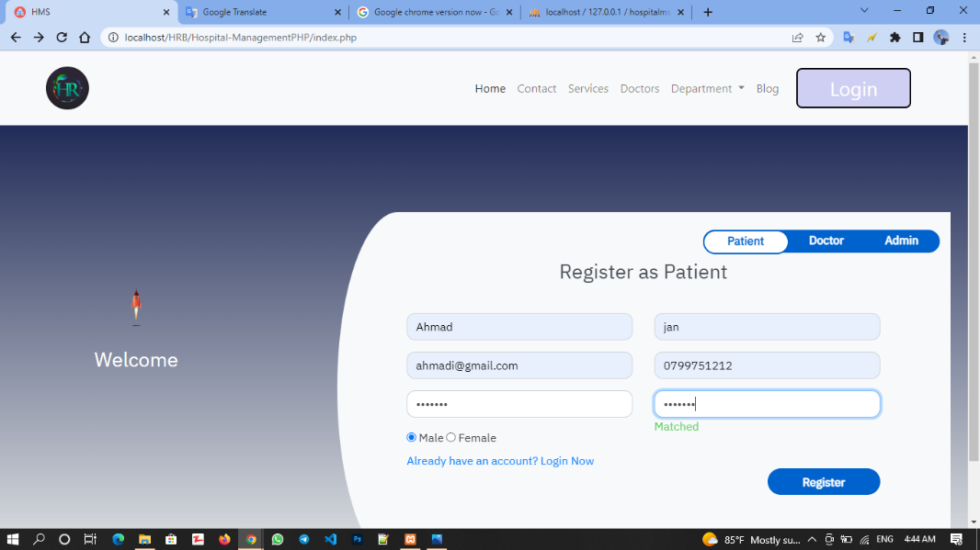

The next page to which the patient will be directed:

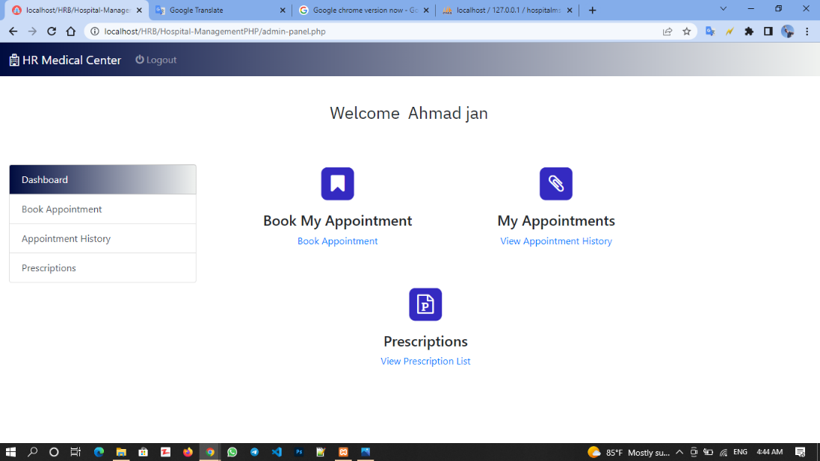

The patient dashboard page has four parts, the first page is the dashboard page itself.

Patient Appointment Page: The second page is the page for making an appointment with the doctor, where the patient can determine the doctor's profile and appointment time.

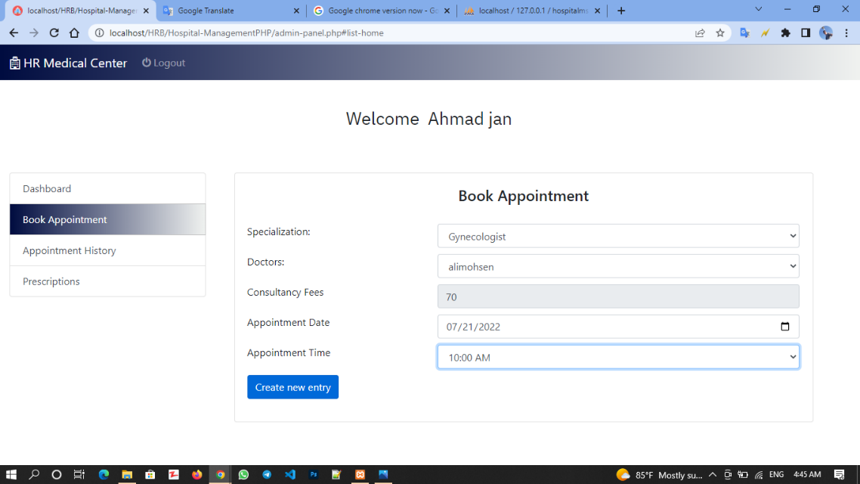

Patient Appointment History Page: In the Appointment History section, the patient can make a previous appointment with the doctor.

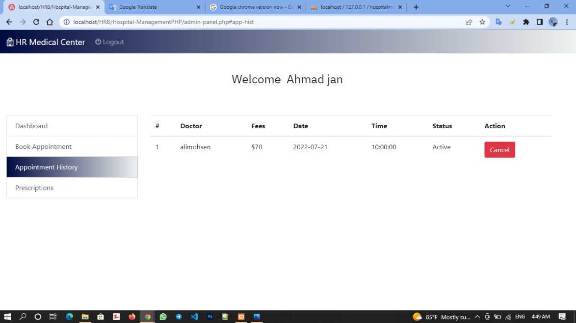

Patient prescription page: In the Prescription section, the patient can see the results of the meeting with the doctor

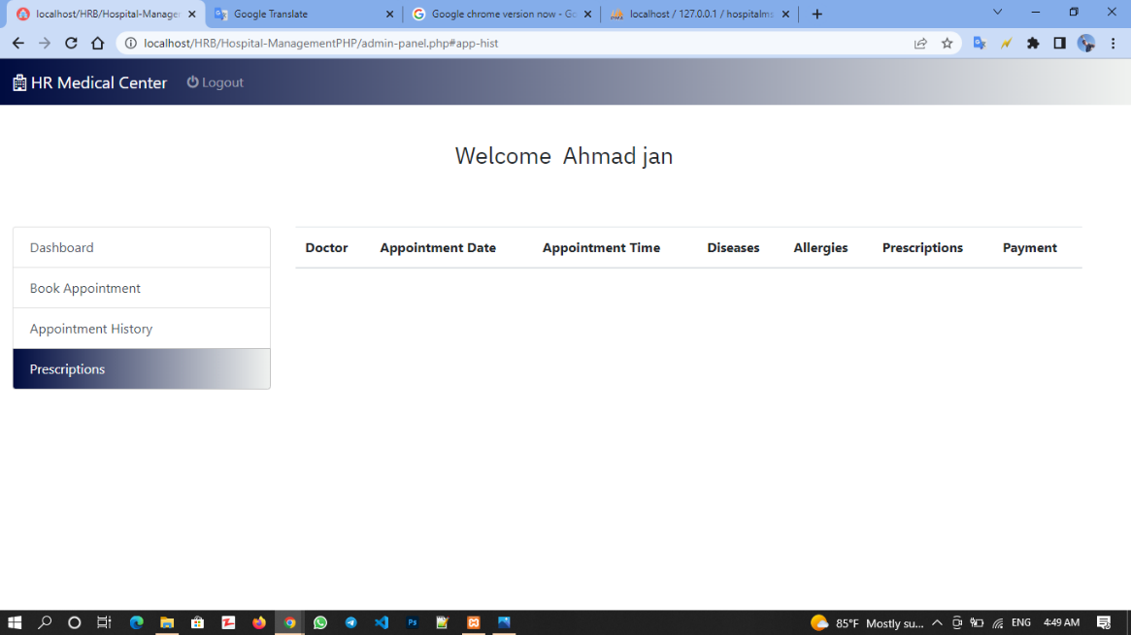

In the Appointment History section, the patient can use the Cancel button to cancel the appointment with the doctor.

The appointment with the patient can be accepted or canceled by the doctor.

After the patient sets his appointment, he should wait for the doctor's answer, and with the doctor's approval, go to the center.  
  
Doctor Activity:

Doctor login Page: Now, if a doctor visits the site, he must go through the following steps.

We assume that our doctor (Ali Mohsen) wants to enter his account, write his email and password in the Login page and enter his dashboard page.

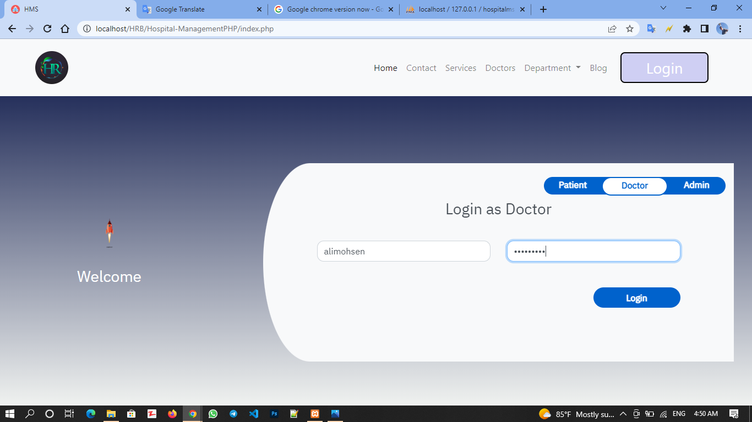

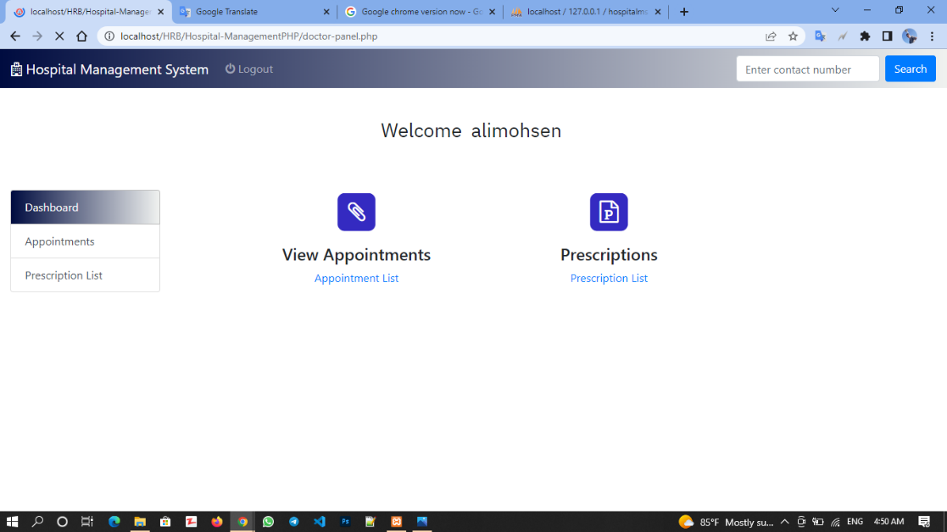Doctor Dashboard: If it is correct, the doctor's email and password will be entered into her account.

Doctor Appointment: The dashboard below Daria has three parts, the dashboard itself through which the doctor can refer to different parts.

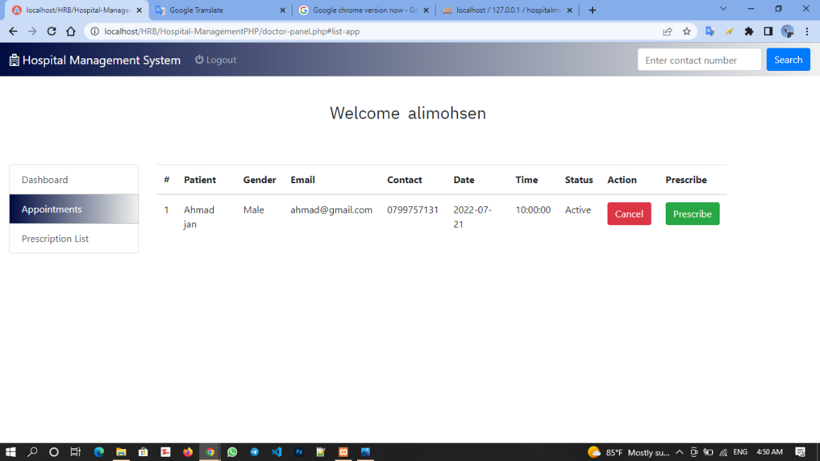Appointment section, in this section, the doctor can schedule appointments requested by patients.

In this section, the doctor can close the patient's profile and confirm or reject the requested appointment.

If the appointment is accepted by the doctor, the doctor and Marish will meet physically, and the doctor can write the results of his examinations in this section.

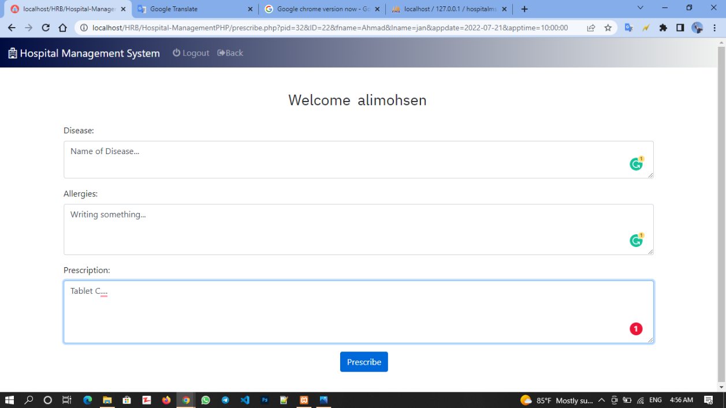Then these details will be visible to the administrator and the patient.

And when he clicks on the PreScrib button, he will enter the following page, which you will return to the first page by clicking on Back to dashboard.

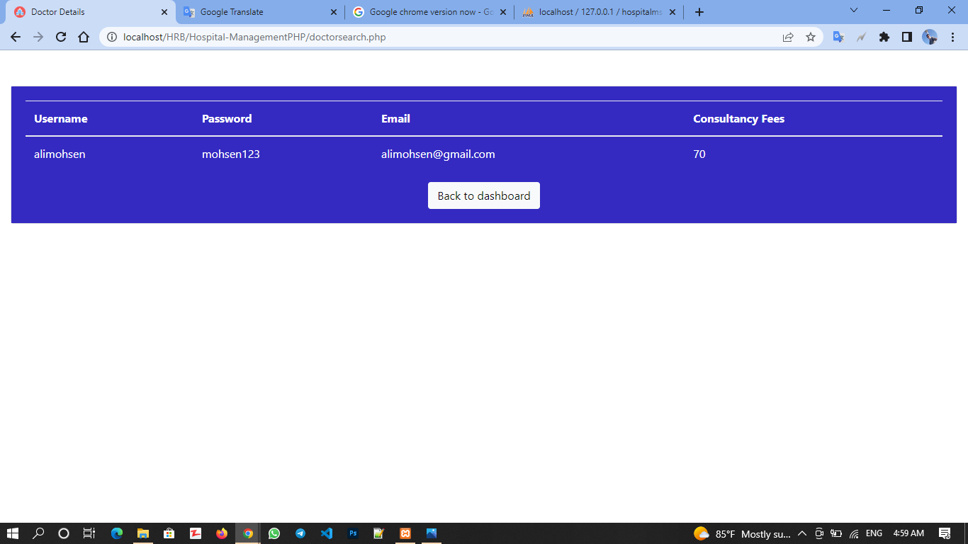

Doctor Prescription list: And in the Prescription List section, the doctor can close the list of the patient's previous visits and the prescriptions she gave to the patient.

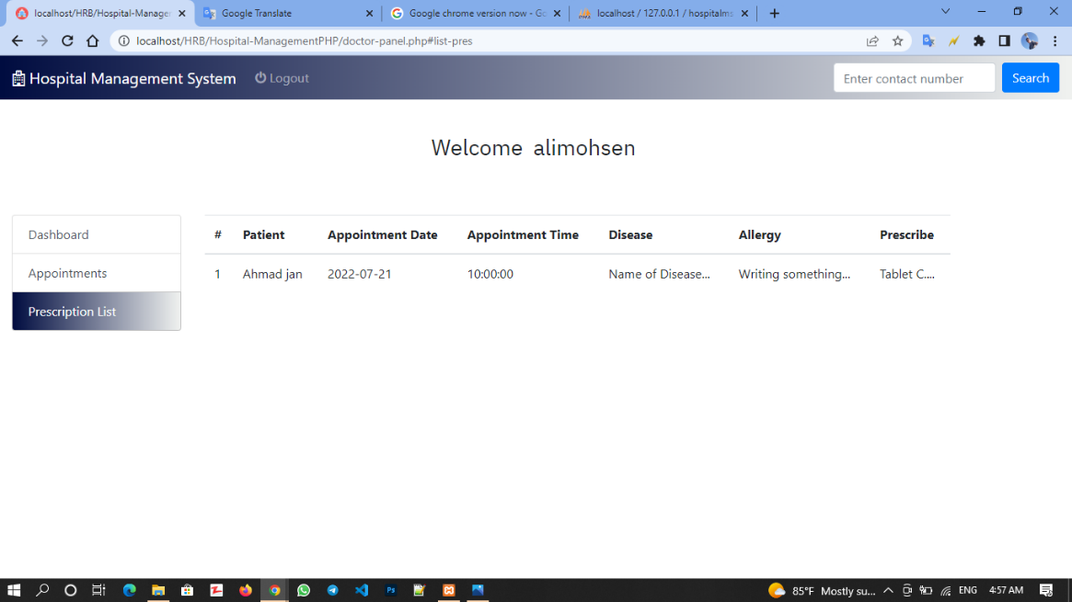

Admin:

Admin login: Now, if the admin wants to enter her page, she can use the login page that is intended for the admin.

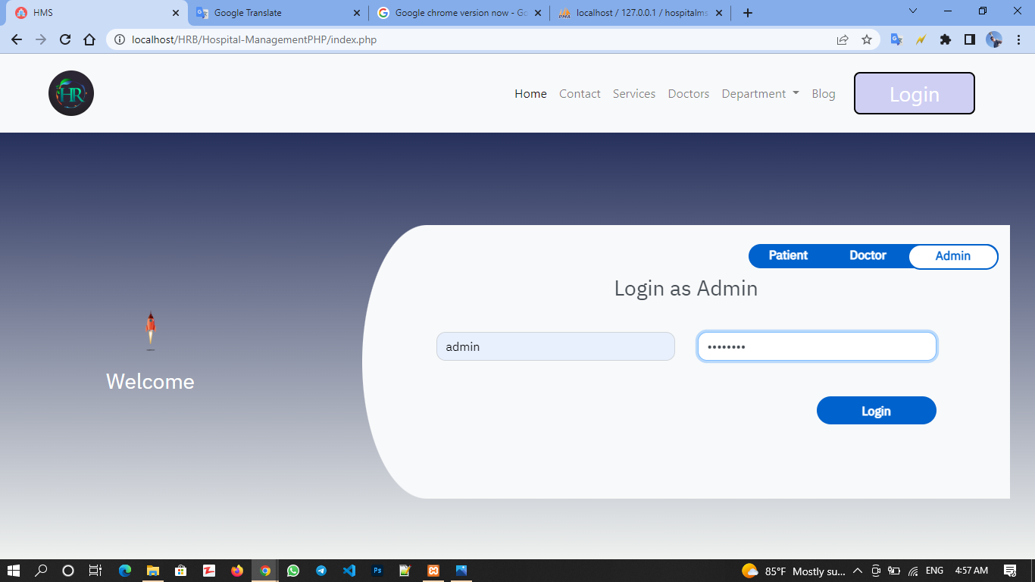

Admin dashboard: After clicking on Login, you will enter the following page

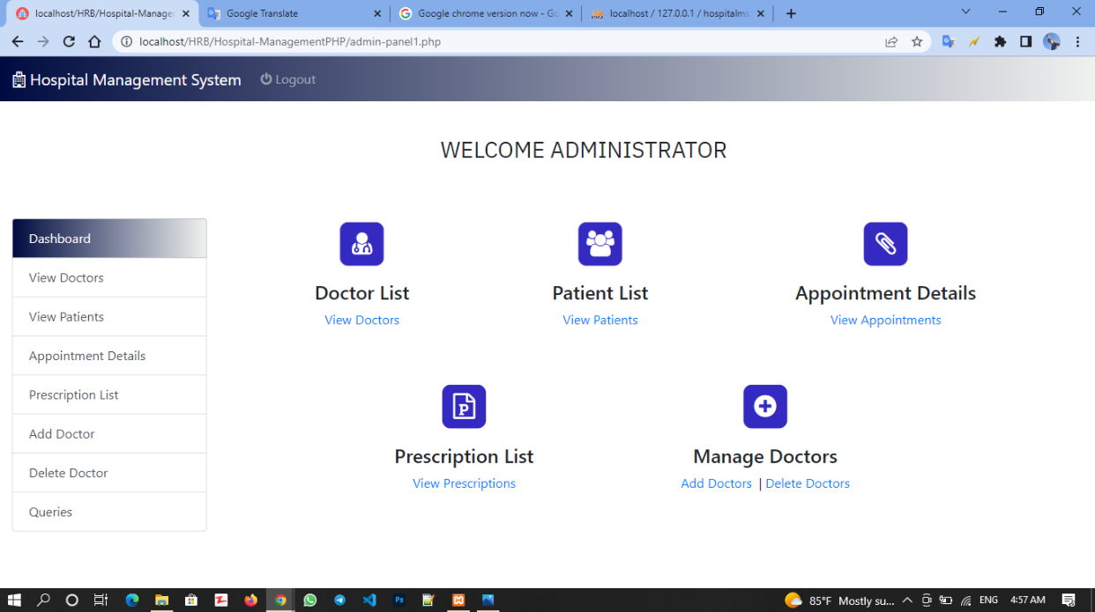

Admin View Doctors page: The admin dashboard has several options, one of which is to show the list of doctors in the center.

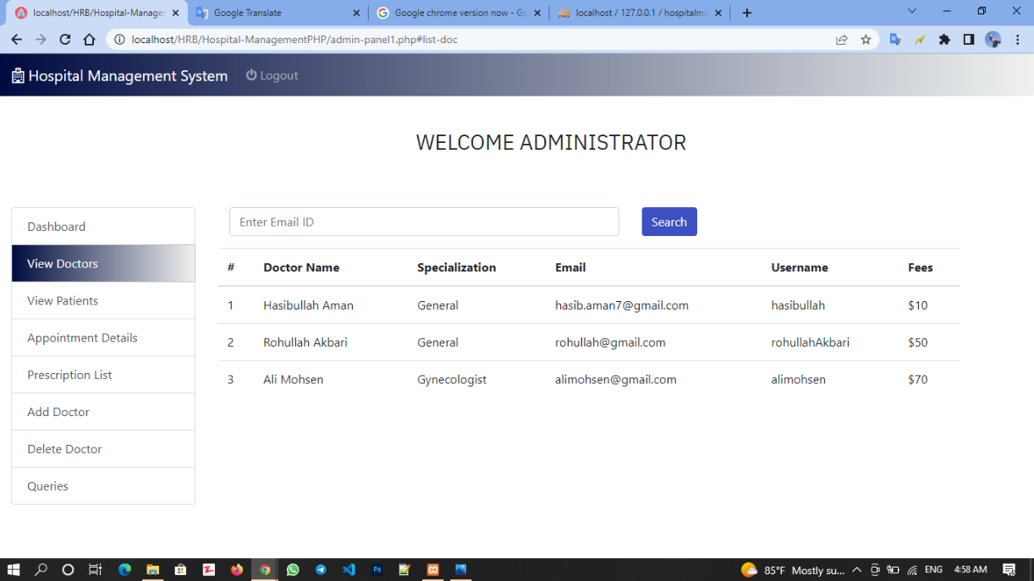

Doctor view patient List: And in the View patient section, the admin can close the list of available patients.

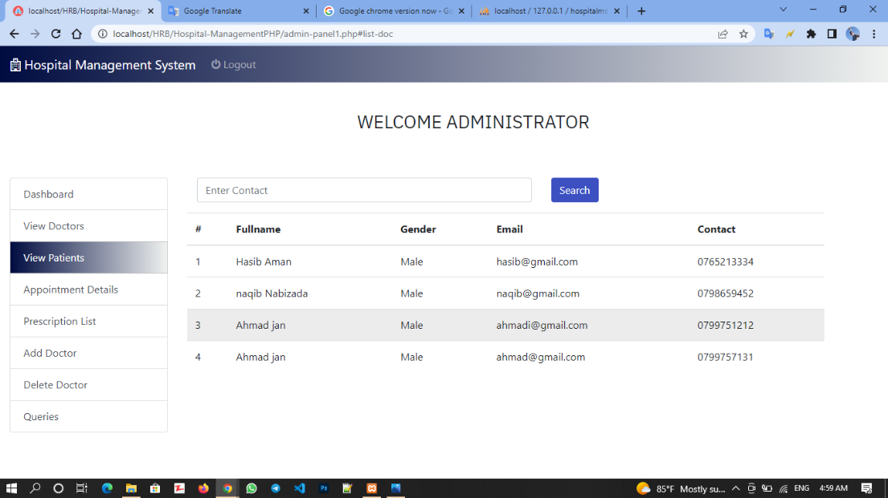

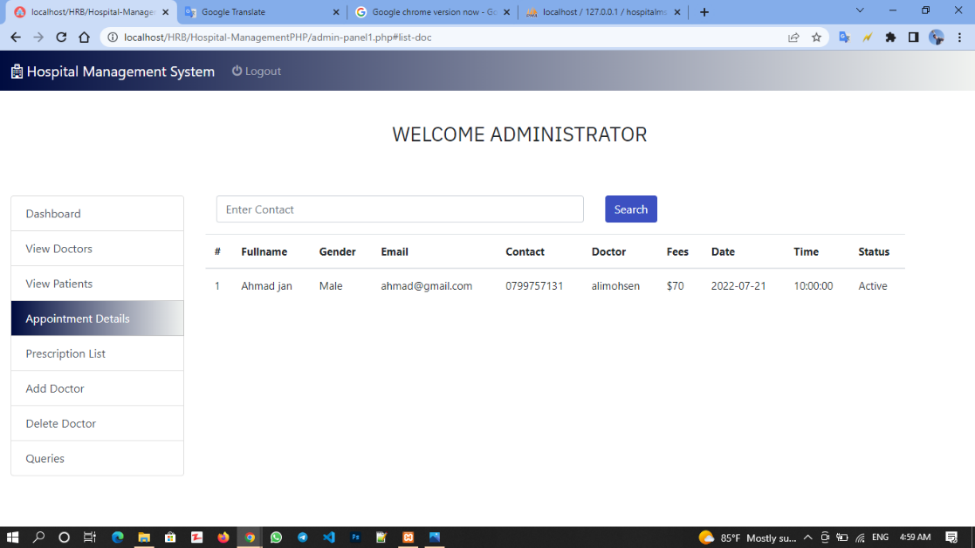Doctor appointment Details: In the Appointment Details section, the admin can close the appointment details.

Doctor Prescription list: In the Prescription list section, the admin can close the list of patients with the characteristics and type of illness, as well as the doctor's diagnosis with the prescribed medicine.

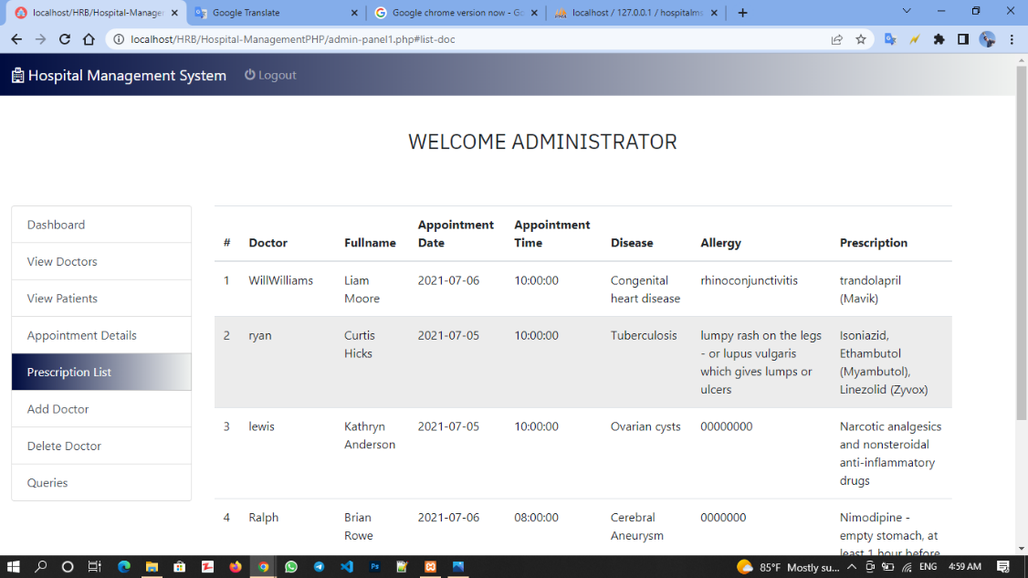

Admin Add doctor page: In the Add Doctor section, the admin can add a doctor to the center, and the same doctor can log in to his account using his password and email.

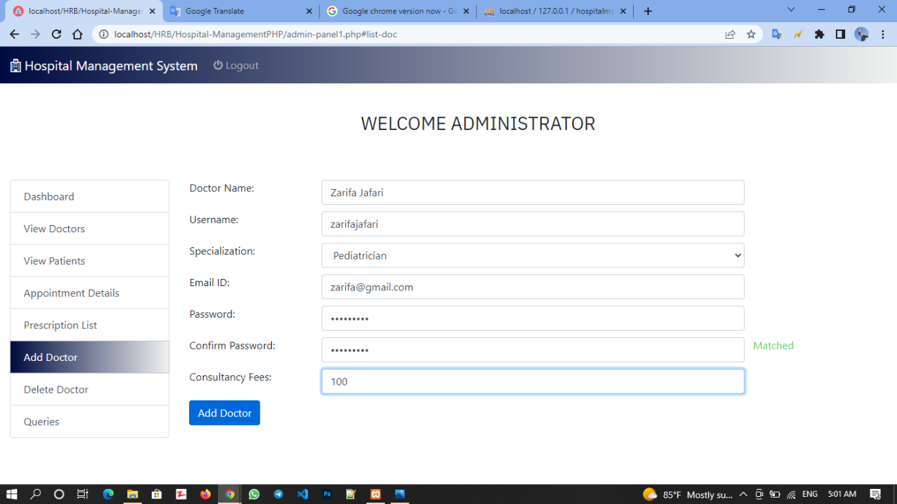We can add a new doctor like the picture below.

Admin delete doctor page: In the Delete Doctor section, the administrator can delete the doctor, by writing the desired doctor's email and clicking on Delete Doctor, the administrator can delete the desired doctor.

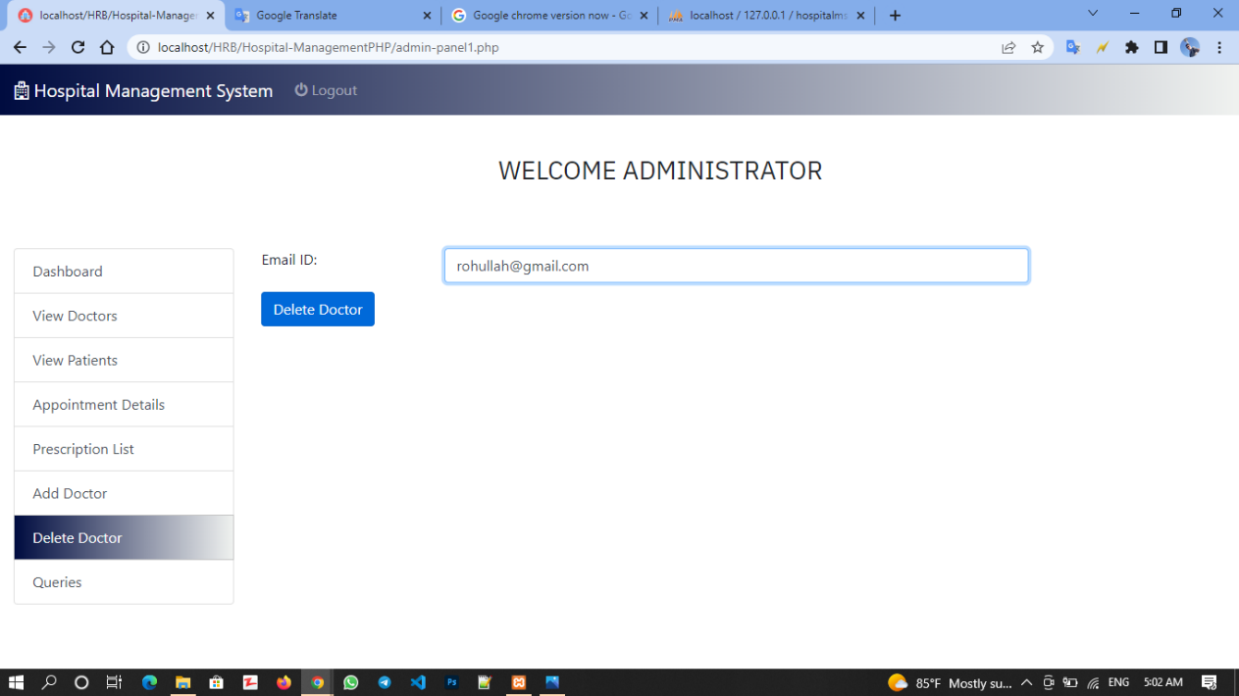

Client contact: One of the other features of our site is that the client can send his opinions and criticisms directly to the site administrator.

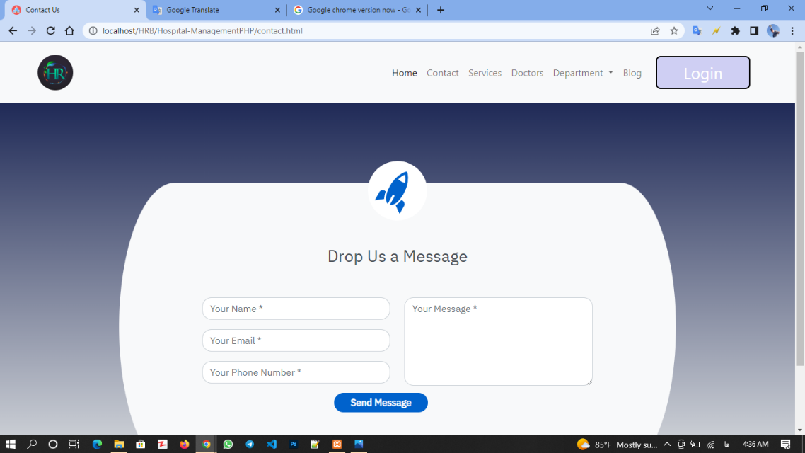By clicking on Contact on our home page, we will be redirected to the following page.

Admin queries page: Later, the site admin can close the opinions of the person in question in the Queries section

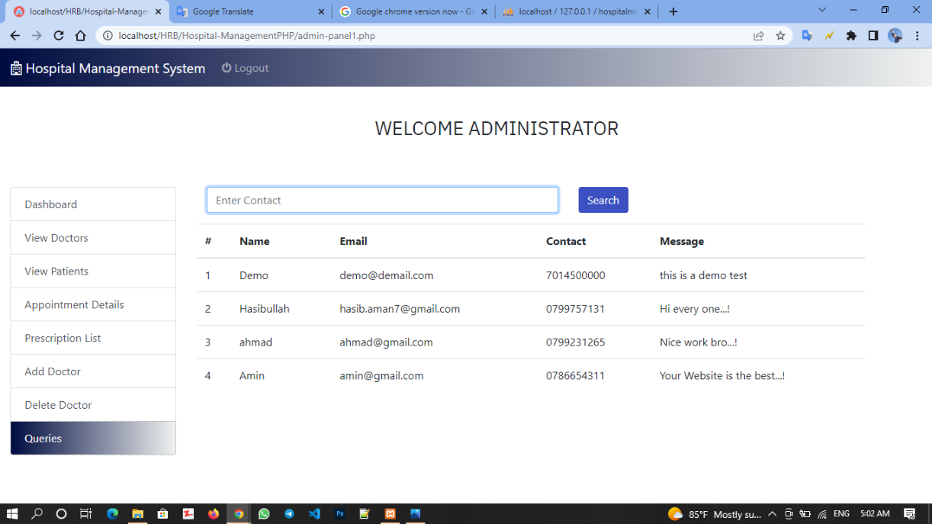

HR Medical Center

Test case

Create Appointment test case:

Use case testing:

|  |  |
| --- | --- |
| **Use Case ID:** |  |
| **Use Case Name:** | Create Appointment |
| **Actors:** | Patient |
| **Description:** | In this use case patient shall be able to create his/her medical checkup appointment by clicking the button |
| **Trigger:** | User clicks on the “create appointment” button. |
| **Preconditions:** | User is logged in the system. |
| **Postconditions:** | System books the user appointment |
| **Normal Flow:** | 1. User logins into the system. 2. User navigates through his/her dashboard. 3. User clicks on the create appointment 4. User fills the form 5. System check availability of the doctor 6. System books the patient appointment if doctor is available. |
| **Alternative Flows:** | N/A |
| **Exceptions:** | 5 In step 5 of the normal flow if the doctor is not available in the specific date of the appointment  1. System shall prompt user to book appointment on another day 2. User books the appointment on another day 3. Appointment created successfully. |
| **Business Rules** | N/A |
| **Assumptions** | 1. User has internet connection. 2. User has a registered account |

Unit testing:

|  |  |  |  |  |  |
| --- | --- | --- | --- | --- | --- |
| **No.** | **Test Case/Test**  **Script** | **Test Data** | **Expected**  **Result** | **Actual**  **Result** | **Pass/Fail/Not**  **Executed/**  **Suspended** |
| 1. | Verify create appointment works properly by clicking on the ‘create’ button and entering  correct data in the form | Appointment name:  Regular checkup  Appointment date: 06-09-  21  Patient name: Ahmad Patient medical card no: 123456 | System creates the user appointment | System shows the success message “appointment created successfully” | Pass |
| 2. | Verify create appointment works properly by clicking on the ‘create’ button and entering no data in the form or incorrect data | Appointment name: retake checkup  Patient name:  Appointment date:  Patient medical card no: | System shows the error message | System generates the message “ fill the required fields” | Pass |

View patient Report Testcase:

Use case testcase:

|  |  |
| --- | --- |
| **Use Case ID:** |  |
| **Use Case Name:** | View Patient Report |
| **Actors:** | Patient |
| **Description:** | In this use case patient shall be able to view report of his/her checkup, lab reports etc. |
| **Trigger:** | User clicks on the “reports” button. |
| **Preconditions:** | User is logged in the system. |
| **Postconditions:** | System schedules the user’s appointment |
| **Normal Flow:** | 1. User logins into the system. 2. User navigates through his/her dashboard. 3. User clicks on the report tab 4. System opens a new window with list of all reports record of the patient 5. User clicks on the report s/he wants to view 6. User views the s/he report. |
| **Alternative Flows:** | N/A |
| **Exceptions:** | N/A |
| **Business Rules** | N/A |
| **Assumptions** | 1. User has internet connection. 2. User has a registered account |

Unit testcase:

|  |  |  |  |  |  |
| --- | --- | --- | --- | --- | --- |
| **No.** | **Test Case/Test**  **Script** | **Test Data** | **Expected**  **Result** | **Actual**  **Result** | **Pass/Fail/Not**  **Executed/**  **Suspended** |
| 1. | Verify view report works properly by clicking on the ‘view’ button of a  report |  | System displays the details of the report | Report details displayed successfully | Pass |

Search Appointment Testcase:  
Use case testcase:

|  |  |
| --- | --- |
| **Use Case ID:** |  |
| **Use Case Name:** | Search Appointment |
| **Actors:** | Doctor |
| **Description:** | In this use case doctor shall be able to search his/her appointments record of the patients by date, name, patient. |
| **Trigger:** | User clicks on the “search” button. |
| **Preconditions:** | User is logged in the system. |
| **Postconditions:** | User searched the appointment successfully by name, patient or date. |
| **Normal Flow:** | 1. User logged in the system. 2. User navigates through his/her dashboard. 3. User clicks on the advance search option 4. User type the appointment name and click search button 5. System displays the appointment details if it is available |
| **Alternative Flows:** | -in step 4 of the normal flow if the user enters the appointment date instead of name  1. System searches the appointment with date and shows data if available  -In step 4 of the normal flow if the user enters the patient’s name instead of appointment name, or date  1. System searches the appointment with date and shows data if available |
| **Exceptions:** | N/A |
| **Business Rules** | N/A |
| **Assumptions** | 1. User has internet connection. 2. User has a registered account |

Unit test Testcase:

|  |  |  |  |  |  |
| --- | --- | --- | --- | --- | --- |
| **No.** | **Test Case/Test**  **Script** | **Test Data** | **Expected**  **Result** | **Actual**  **Result** | **Pass/Fail/Not**  **Executed/**  **Suspended** |
| 1. | Verify search appointment by name works by clicking on the ‘search’ button and entering  correct appointment name | Appointment name: Regular checkup | System searches and shows the appointment record | System shows the appointment record | Pass |
| 2. | Verify search appointment by name works by clicking on the ‘search’ button and entering  incorrect appointment name that doesn’t exist | Appointment name: retake checkup | System shows the message “no result found” | System generates the message “no result found” | Pass |
| 3. | Verify search appointment by patient name works by clicking on the ‘search’ button and entering correct data | Patient name: John doe | System shows  the list of all recent appointment of john doe | System displays the list of  appointment for the john doe | Pass |
| 3. | Verify search appointment by patient name works by clicking on the ‘search’ button and entering incorrect appointment name that doesn’t exist | Patient Name: test demo | System shows the message “no result found | System generates the message “no result found” | Pass |
| 4. | Verify search appointment by date works by clicking on the ‘search’ button and entering a date | Date: 06/09/21 | System shows  the list of  appointment on this date. | System  displays the list of all  appointment on this date | Pass |

Manage Staff testcase:

Use case testcase:

|  |  |
| --- | --- |
| **Use Case ID:** |  |
| **Use Case Name:** | Manage Staff |
| **Actors:** | Admin |
| **Description:** | Admin shall be able to manage the record of healthcare staff members. S/he can update, add, delete a record of staff. |
| **Trigger:** | User clicks on the “manage staff” tab |
| **Preconditions:** | User is logged in the system. |
| **Postconditions:** | User manages the staff record successfully. System allows him/her to edit, delete. Create staff member record. |
| **Normal Flow:** | 1. User logged in the system. 2. User navigates through his/her dashboard. 3. User selects the one of the options delete, add, update record 4. System adds, delete, or update the record. |
| **Alternative Flows:** | N/A |
| **Exceptions:** | N/A |
| **Business Rules** | N/A |
| **Assumptions** | 1. User has internet connection. 2. User has a registered account |

Unit test testcase:  
Add staff:

|  |  |  |  |  |  |
| --- | --- | --- | --- | --- | --- |
| **No.** | **Test Case/Test**  **Script** | **Test Data** | **Expected**  **Result** | **Actual**  **Result** | **Pass/Fail/Not**  **Executed/**  **Suspended** |
| 1. | Verify that after click on the ‘Add Staff’ button adds New Staff member with  correct input data  in the form | Id:1  First name: Ahmad  Last Name: Jan  Department: accounts  Phone: 0799757131  Address: Kabul  Gender: Male  Dob: 1997-03-06 | Success message is shown | Success message is shown “Staff member added successfully” | Pass |
| 2. | Verify Add Staff works after click on the ‘Add Employee’ button and adding staff form with empty data. | Id:  First name:  Last Name:  Department:  Phone:  Address:  Gender:  Dob: | Error Message is shown | Empty fields are highlighted | Pass |

Delete Staff:

|  |  |  |  |  |  |
| --- | --- | --- | --- | --- | --- |
| **No.** | **Test Case/Test**  **Script** | **Test Data** | **Expected**  **Result** | **Actual**  **Result** | **Pass/Fail/Not**  **Executed/**  **Suspended** |
| 1. | Verify Delete Staff works properly after clicking on the ‘Delete’ icon |  | Page is loaded with fresh data. | Page is reloaded after the desire staff data deleted | Pass |

Edit Staff:

|  |  |  |  |  |  |
| --- | --- | --- | --- | --- | --- |
| **No.** | **Test Case/Test**  **Script** | **Test Data** | **Expected**  **Result** | **Actual**  **Result** | **Pass/Fail/Not**  **Executed/**  **Suspended** |
| 1. | Verify Edit Staff works by clicking on the ‘Update’ button on Edit Employee form with correct input data. | Id:1  First name: Ahmad  Last Name: Jan  Department: HR  Phone: 0799757131  Address: Kabul  Gender: male  Dob: 1997-03-06 | Success message is shown | System generate Success message “Record Updated successfully” | Pass |

1. Windows 10:photo is taken from window 10 operating system.